|  |  |
| --- | --- |
| **Ex. No. 8** | **WEB APPLICATION DEVELOPMENT USING ANGULARJS FRAMEWORK** |
| **Date of Exercise** | 27/02/2023 |

**Aim**

To Create a website using HTML, CSS and AngularJS client side Model, View and Controller Framework.

**Description**

**Document object Model:**

Represents the HTML document that is displayed * Has various properties which to objects that allows to and access modification of document content. It is called Dom

Finding HTML elements:

By ld: document.getElementById("<id>");

By Tag Name: document.getElementsByTagName("<tagname>);

By class Name: document.getElementsbyclassName("<class_name>");

By css selectors: document.querySelectorall("<selector>");

Javascripts interaction with HTML is handled through many events some of them were as follows:

* occus when the user (s) browser manipulate it.
* onload : triggered while document loads
* onclick: triggers on a mouse click Triggers when an element changes.
* onkeyup: Triggers when a key is released
* onkey down: Triggers when a key is pressed.
* onsubmit: Triggers when a form is submitted
* onmouseover: Triggers when a mouse pointer over it.
* onmousedown. Triggers when a mouse button is pressed.

**Program**

1.

<!DOCTYPE html>

<html lang="en">

<head>

<meta charset="UTF-8">

<meta http-equiv="X-UA-Compatible" content="IE=edge">

<meta name="viewport" content="width=device-width, initial-scale=1.0">

<title>Employee Payroll Calculation</title>

<script src="angular.js"></script>

<script>

var myEmpApp = angular.module("emp_payroll", []);

myEmpApp.controller("control1", function($scope) {

$scope.sal_cal = function() {

$scope.e_name = $scope.emp_name;

$scope.e_id = $scope.emp_id;

$scope.s_date = $scope.sal_date.getDate()+"/"+$scope.sal_date.getMonth()+"/"+$scope.sal_date.getFullYear();

$scope.gross_sal = Number($scope.basic_sal) + Number($scope.hra) + Number($scope.da);

var tax_amt;

if ($scope.gross_sal > 60000) {

tax_amt = $scope.gross_sal * 0.15;

} else if ($scope.gross_sal > 40000) {

tax_amt = $scope.gross_sal * 0.1;

} else if ($scope.gross_sal > 20000) {

tax_amt = $scope.gross_sal * 0.05;

}

$scope.net_sal = $scope.gross_sal - tax_amt;

$scope.tax = tax_amt;

}

});

</script>

<style>

label{

display: inline-block;

width: 150px;

color: blue;

}

input{

margin: 10px;

padding: 2px;

color: red;

}

h4{

margin-left: 100px;

}

.tle{

display: inline-block;

width: 120px;

background-color: blue;

color: white;

text-align: center;

}

span{

padding-left: 5px;

}

</style>

</head>

<body ng-app="emp_payroll">

<h2>Employee Payroll Calculator</h2>

<div ng-controller="control1">

<form>

<label for="emp_name">Employee Name:</label>

<input type="text" id="emp_name" ng-model="emp_name"><br>

<label for="emp_id">Employee ID:</label>

<input type="text" id="emp_id" ng-model="emp_id"><br>

<label for="sal_date">Salary Date:</label>

<input type="date" id="sal_date" ng-model="sal_date"><br>

<label for="basic_sal">Basic Salary:</label>

<input type="number" id="basic_sal" ng-model="basic_sal"><br>

<label for="hra">House Rent Allowance</label>

<input type="number" id="hra" ng-model="hra"><br>

<label for="da">Dearness Allowance</label>

<input type="number" id="da" ng-model="da"><br>

<button ng-click="sal_cal()" type="button">Calculate Salary</button>

</form>

<h4>Salary Details</h4>

<p>

<p class="tle">Employee Name</p><span>{{e_name}}</span><br>

<p class="tle">Employee ID</p><span>{{e_id}}</span><br>

<p class="tle">Salary Date</p><span>{{s_date}}</span><br>

<p class="tle">Gross Salary</p><span>Rs.{{gross_sal}}</span><br>

<p class="tle">Net Salary</p><span>Rs.{{net_sal}}</span><br>

<p class="tle">Tax Deducted</p><span>Rs.{{tax}}</span>

</p>

</div>

</body>

</html>

2.

<!DOCTYPE html>

<html>

<script src="https://ajax.googleapis.com/ajax/libs/angularjs/1.6.9/angular.min.js"></script>

<link

href="https://cdn.jsdelivr.net/npm/bootstrap@5.3.0-alpha1/dist/css/bootstrap.min.css"

rel="stylesheet">

<script>

var app = angular.module('myApp', []);

app.controller("myCtrl", function($scope){

$scope.arr = [];

$scope.myFunc = function(){

$scope.arr.push({name:$scope.i1, price:$scope.i2});

$scope.i1=null;

$scope.i2=null;

}

$scope.removeItem = function($index){

$scope.arr.splice($index, 1);

}

});

</script>

<body ng-app="myApp" ng-controller="myCtrl">

<h1 class="text-bg-dark text-center py-2">Product Inventory System</h1>

<div class="row d-flex justify-content-center">

<div class="form-group px-5 col-6">

<label for="name">Product Name</label>

<input type="text" class="form-control" name="name" ng-model="i1" value="10"

required>

<label for="price">Product Price</label>

<input type="number" class="form-control" name="price" ng-model="i2" value="10"

min="0"><br>

<div class="text-center">

<input type="button" value="Add Product" class="btn btn-dark" ng-click="myFunc()">

</div>

</div>

</div>

<hr>

<div class="row d-flex justify-content-center">

<div class="px-5 col-7">

<table class="table text-center" ng-model="table">

<thead class="table-dark">

<tr>

<th>Name</th>

<th>Price</th>

<th>Remove</th>

</tr>

</thead>

<tbody>

<tr ng-repeat="x in arr track by $index">

<td>{{x.name}}</td>

<td>{{x.price}}</td>

<td><button value="Delete" ng-click="removeItem($index)">Remove</button></td>

</tr>

</tbody>

</table>

</div>

</div>

</body>

</html>

**Output**

**1.**

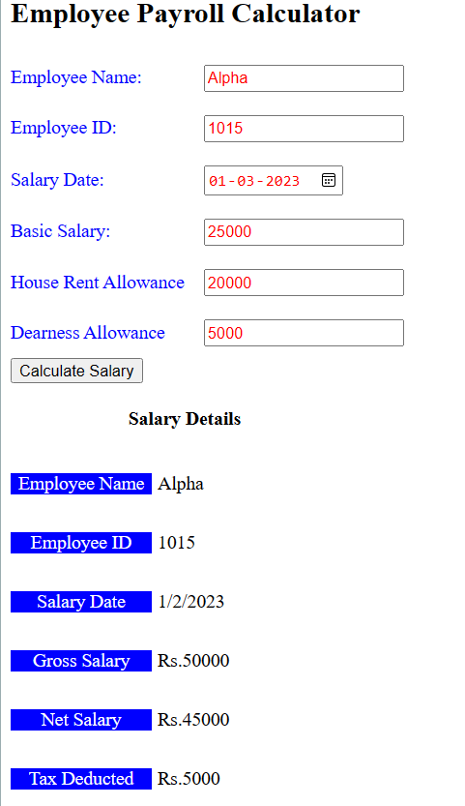

**2.**

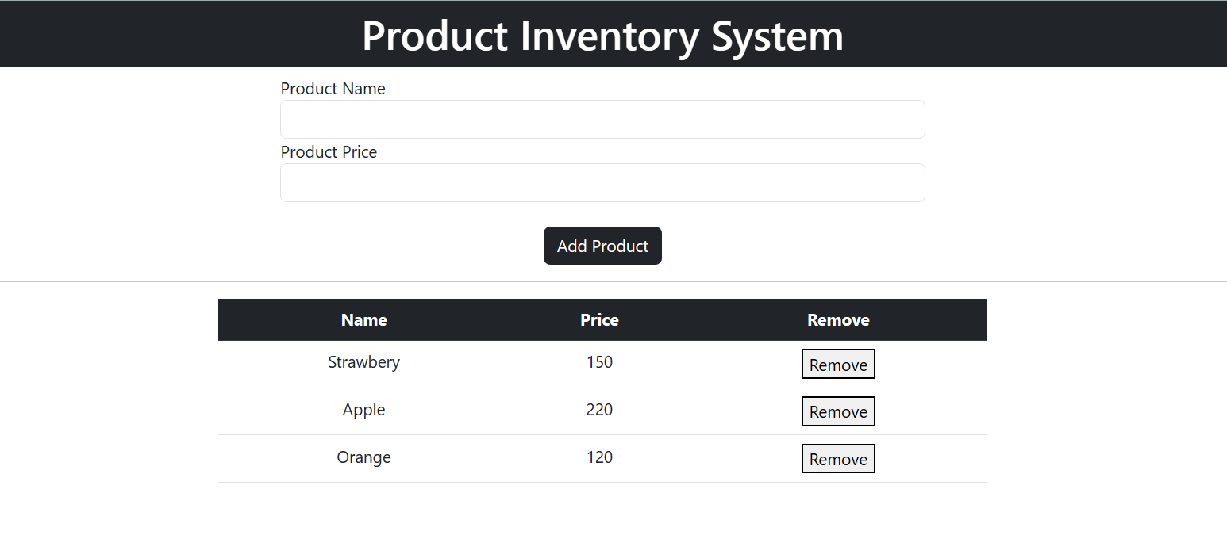

**Result**

The website using HTML, CSS and AngularJS client side Model, View and Controller Framework has been executed successfully and the desired output is displayed on the screen.